**IKEM MERCY OGECHI**

**INFO8845-23S**

**8859960**

**RAPHAEL ADEYEMO**

**8TH JUNE 2023.**

Contents

**DESCRIPTION** 1

**PREPARATION** 1

**OBSERVATION** 2

**SCREENSHOT** 2

**REFLECTION** 10

**1.** **What is Steganalysis?** 10

**2.** **What is the difference between cryptography and steganography?** 10

**3.** **What is unique about messages transmitted using steganography?** 10

**4.** **What are the basic steganographic concepts or inputs and outputs?** 11

**REFERENCE** 11

## **DESCRIPTION**

In this lab, I will study steganography, file headers, and data integrity in this lab. The tasks include various calculations and comparisons of file hashes, examination of the hashes, examination of file hashes, examination of file header data, and use of steganography tools like S-Tools. The underlying structures of various file types, including text files and rich text files, will be examined, and understood by you. You will also practice using steganography techniques to hide and reveal messages that are hidden within files. The lab aims to improve your comprehension of metadata, hidden information detection, and file manipulation in digital and file manipulation in digital forensics.

## **PREPARATION**

• I connected to the school VPN.

• I connected to my vSphere and deployed window 10.

• I downloaded autopsy 4.20.0.

## **OBSERVATION**

In the lab, we looked at the idea of file hashes and their importance in maintaining data integrity. We used applications like Nirsoft Hashmyfiles to calculate and compare file hashes. It was fascinating to see how the diffusion property of hashes caused even a slight change in the original data to have a significant impact on the hash output. We also looked at file headers and how they contribute to the knowledge of files contents and formats. We also explored the field of steganography, which allows messages to be concealed within other files, The significance of recognizing steganography in digital forensics investigations was thus made clear to us.

## **SCREENSHOT**

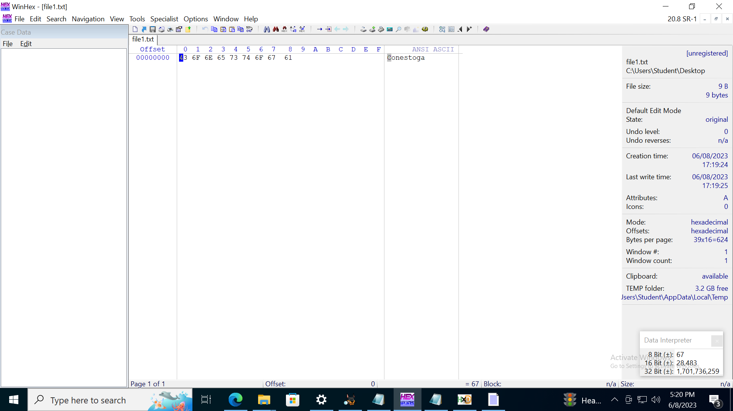

Fig 1 shows the information contents in file I when I opened it using WinHex.

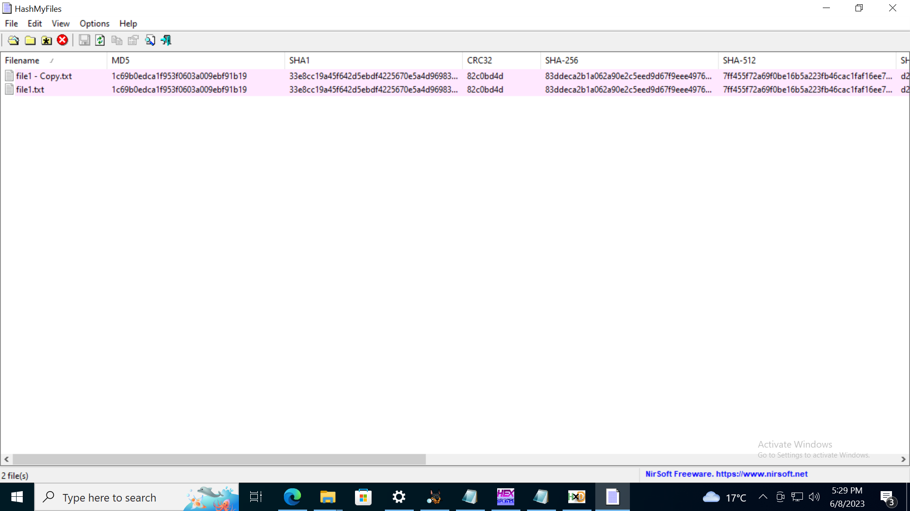

Fig 2 shows the hash information of the two files.

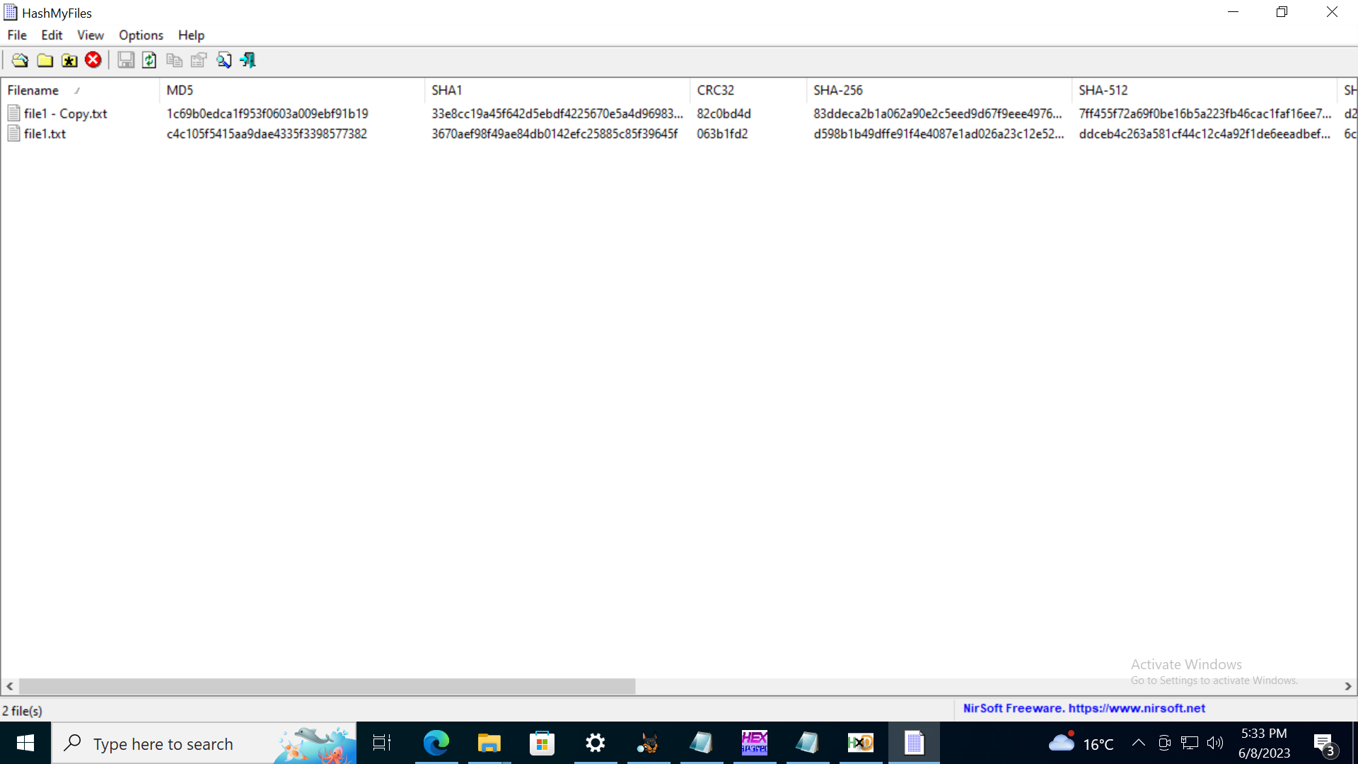

Fig 3 shows the difference between the two files because I altered the file txt.

TASK 2

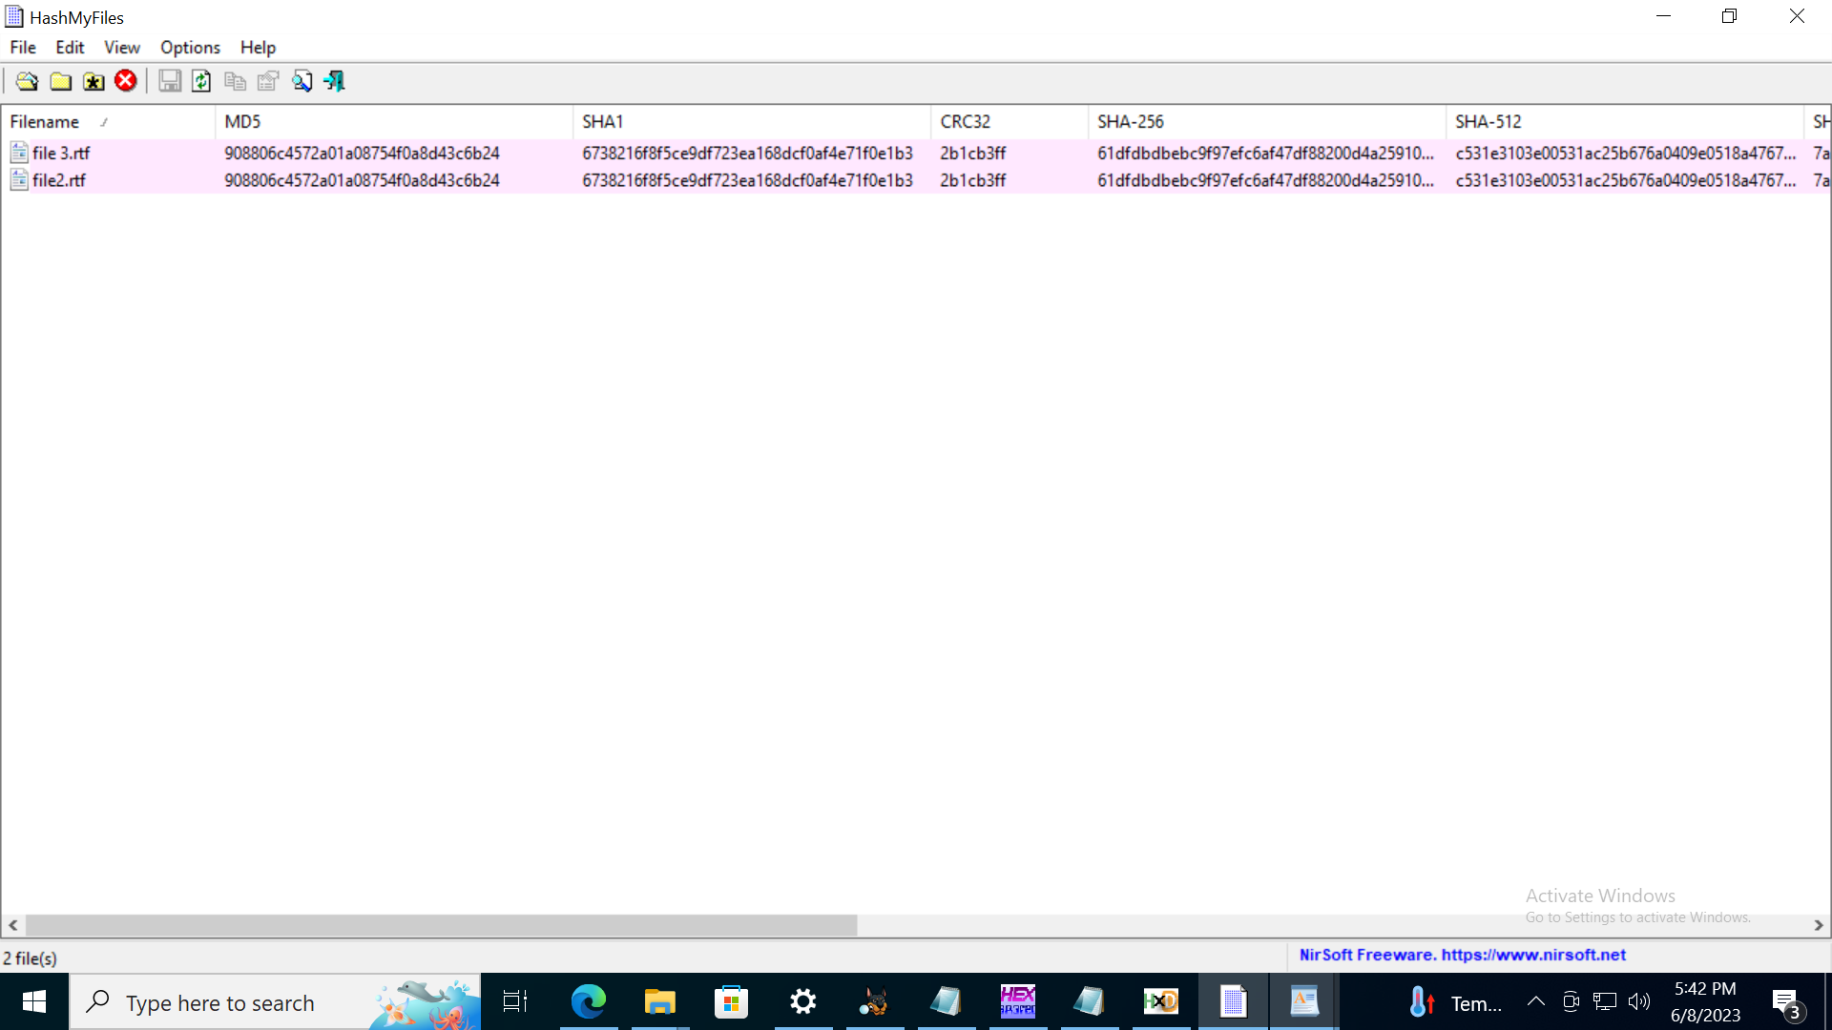

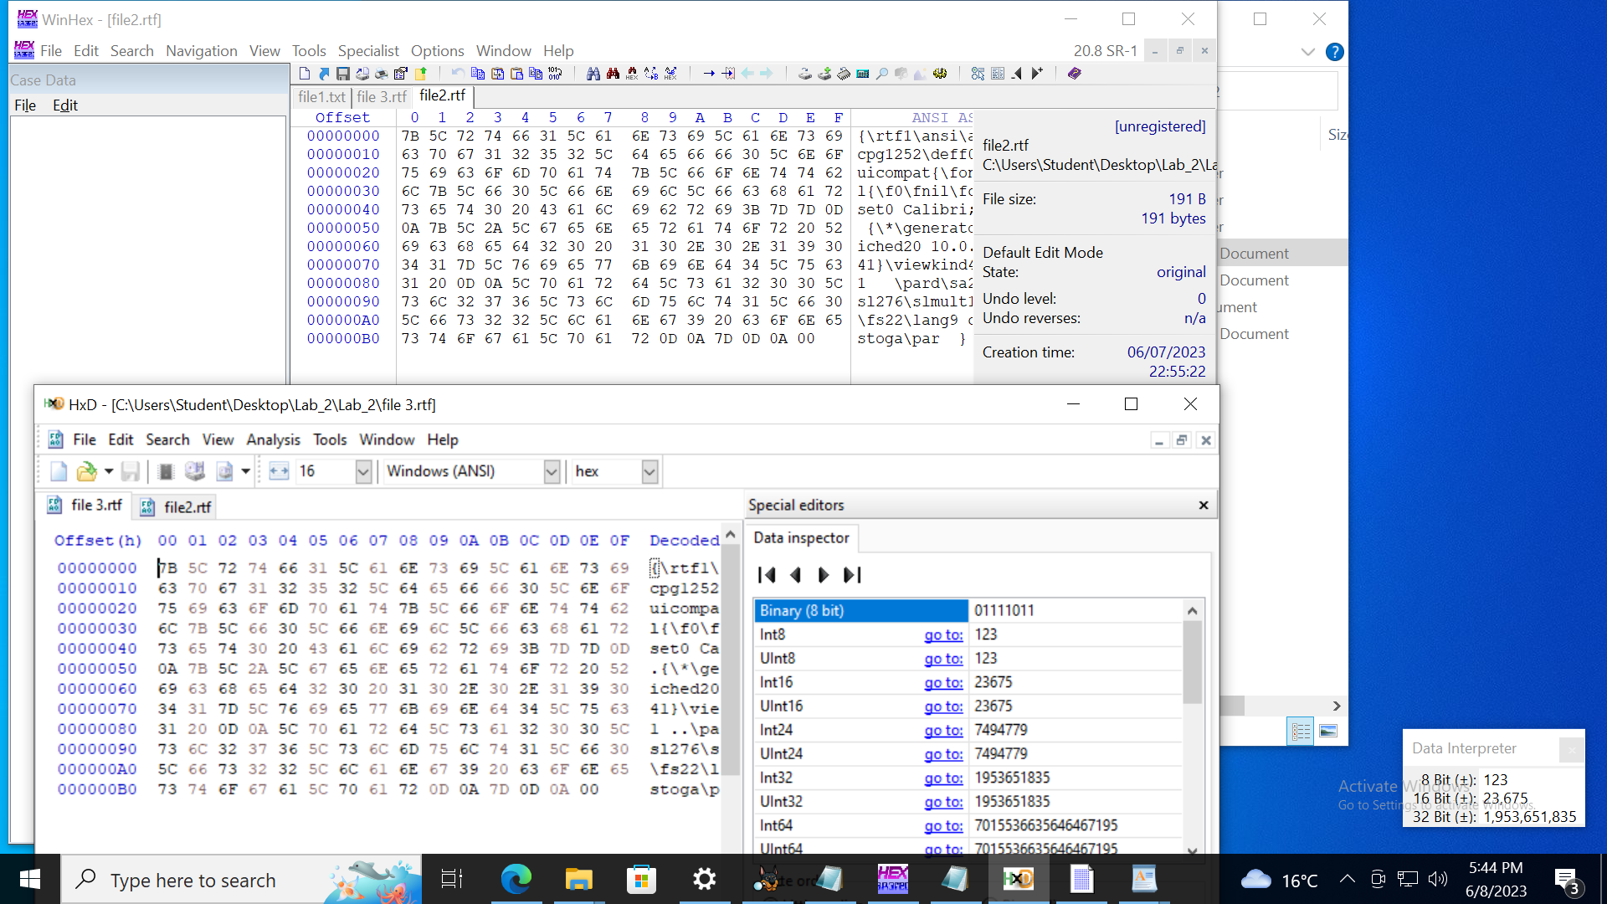

Fig 4 shows the result using both winhex and HxD.

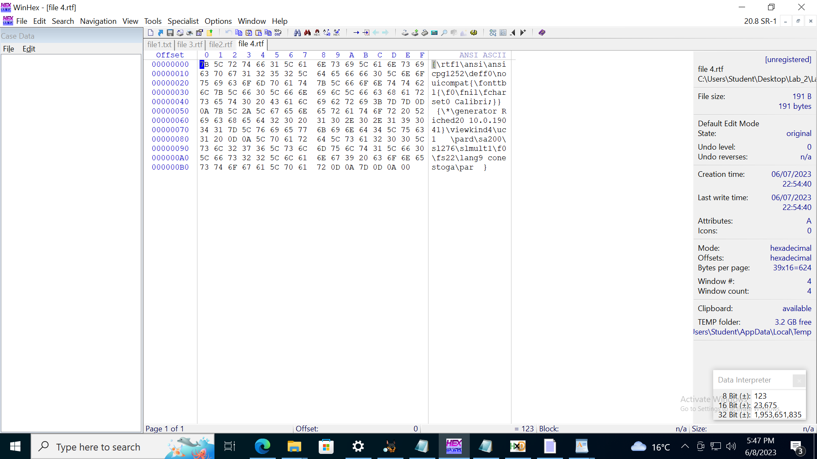

Fig

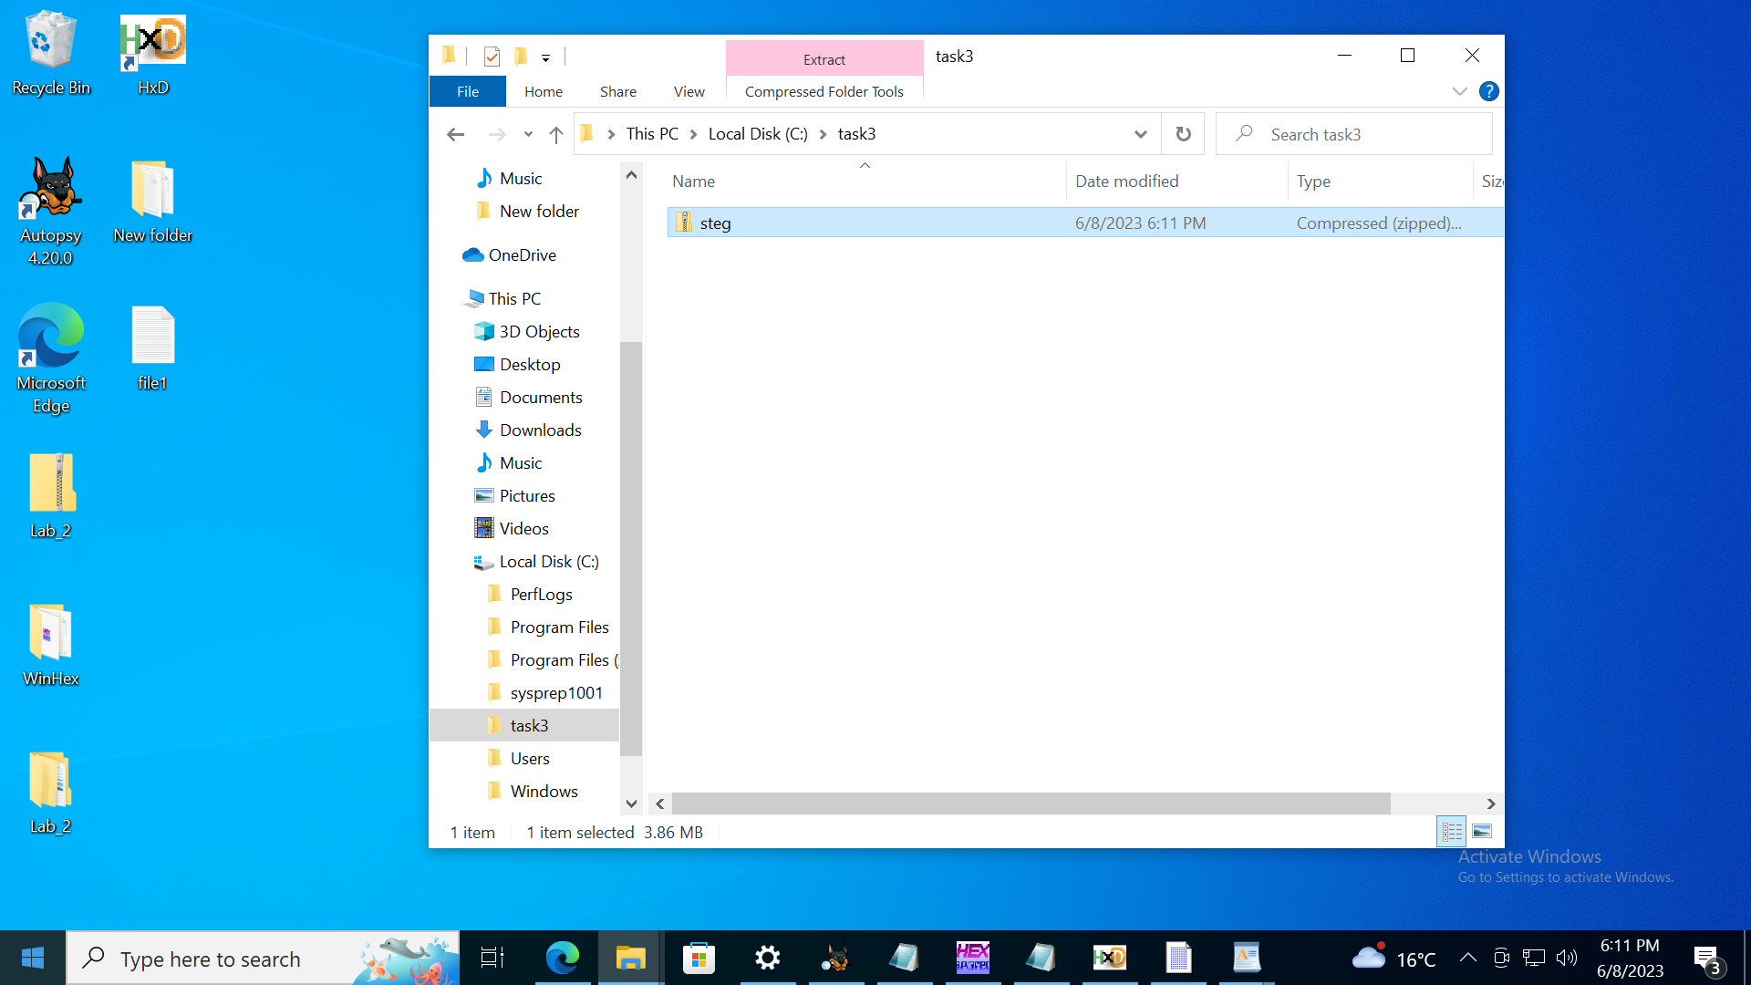

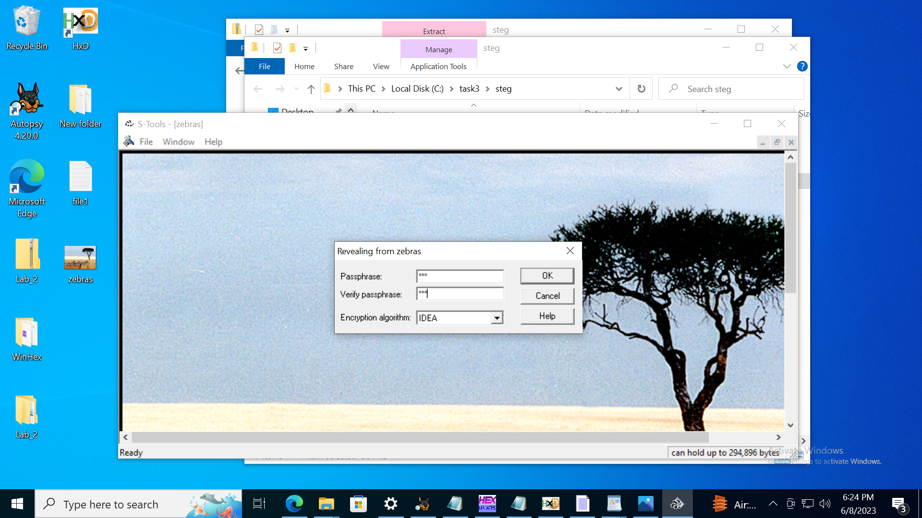

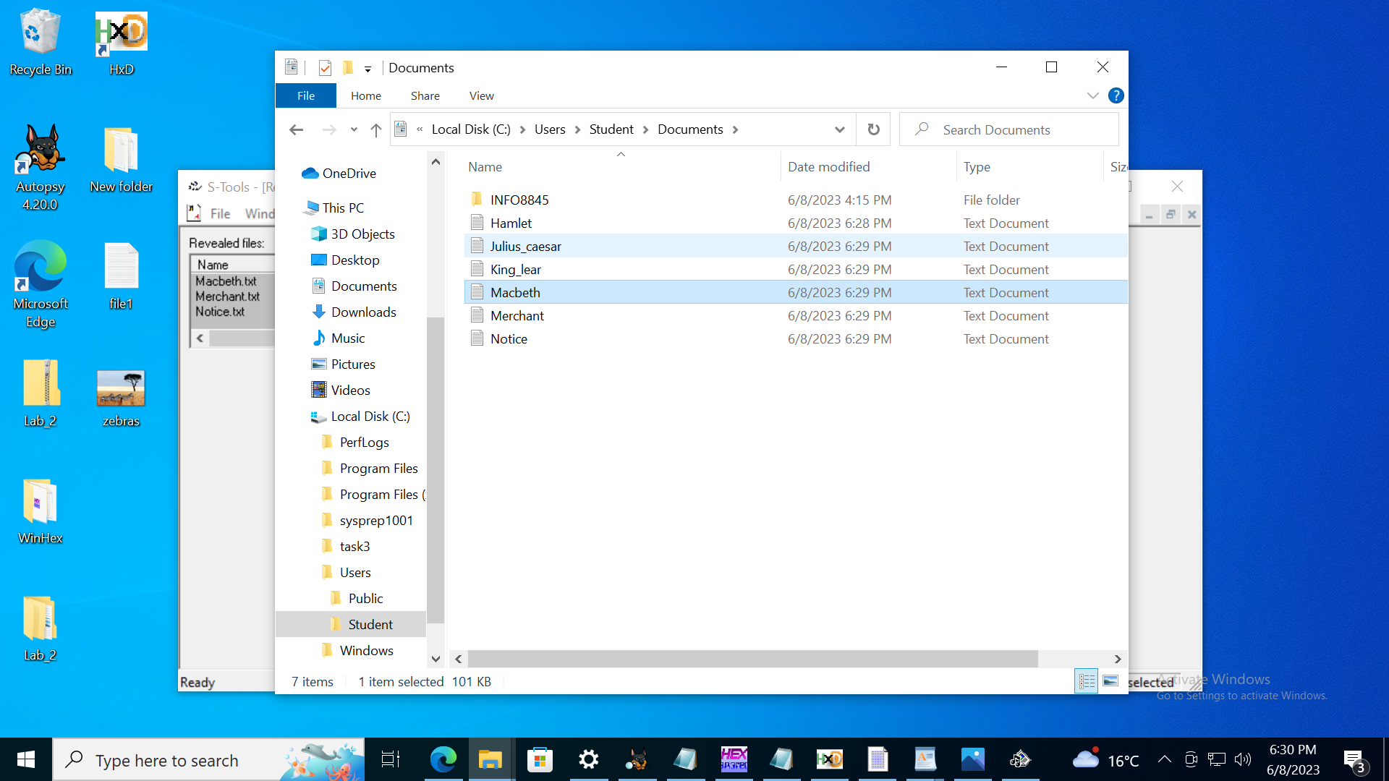

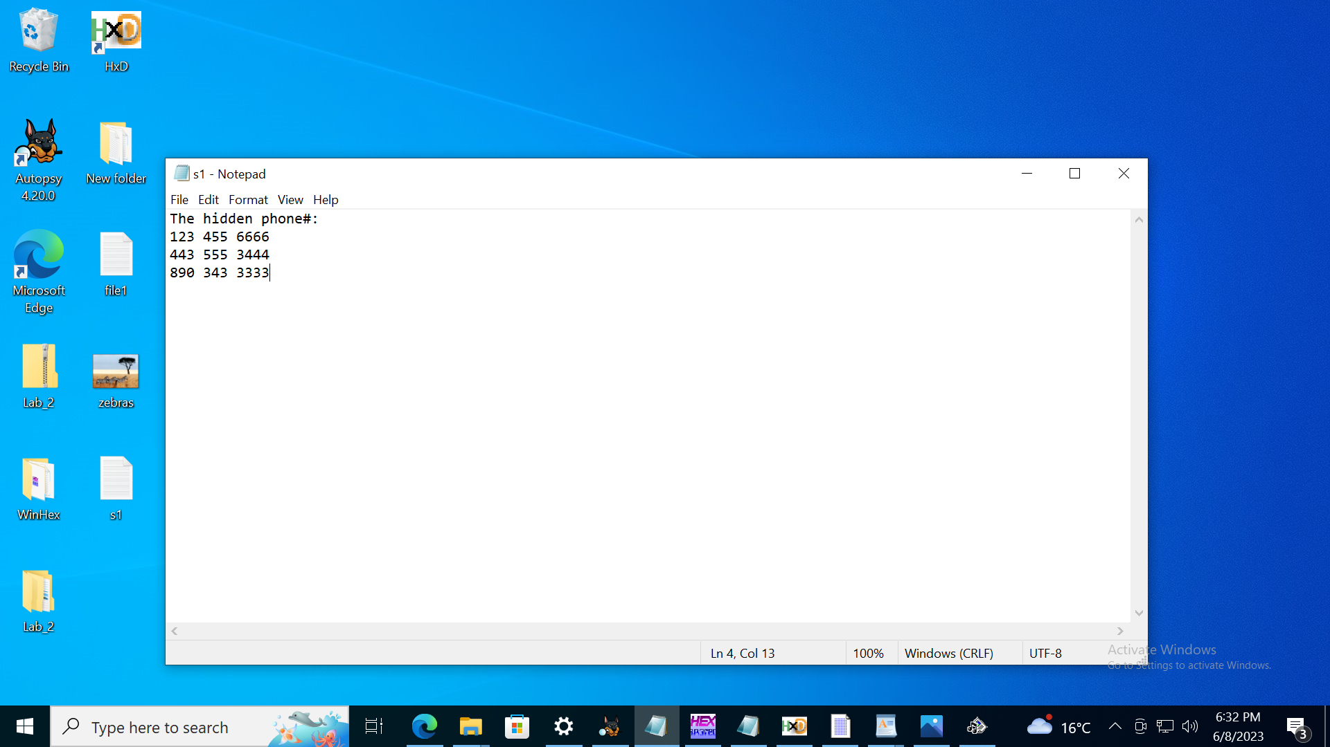

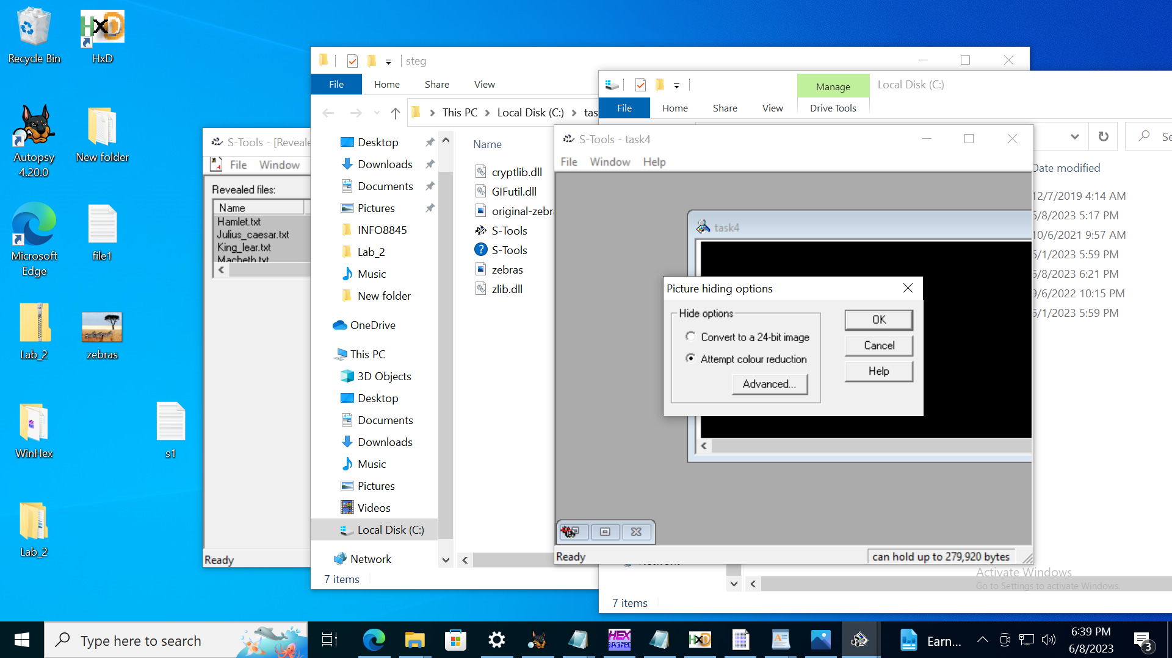

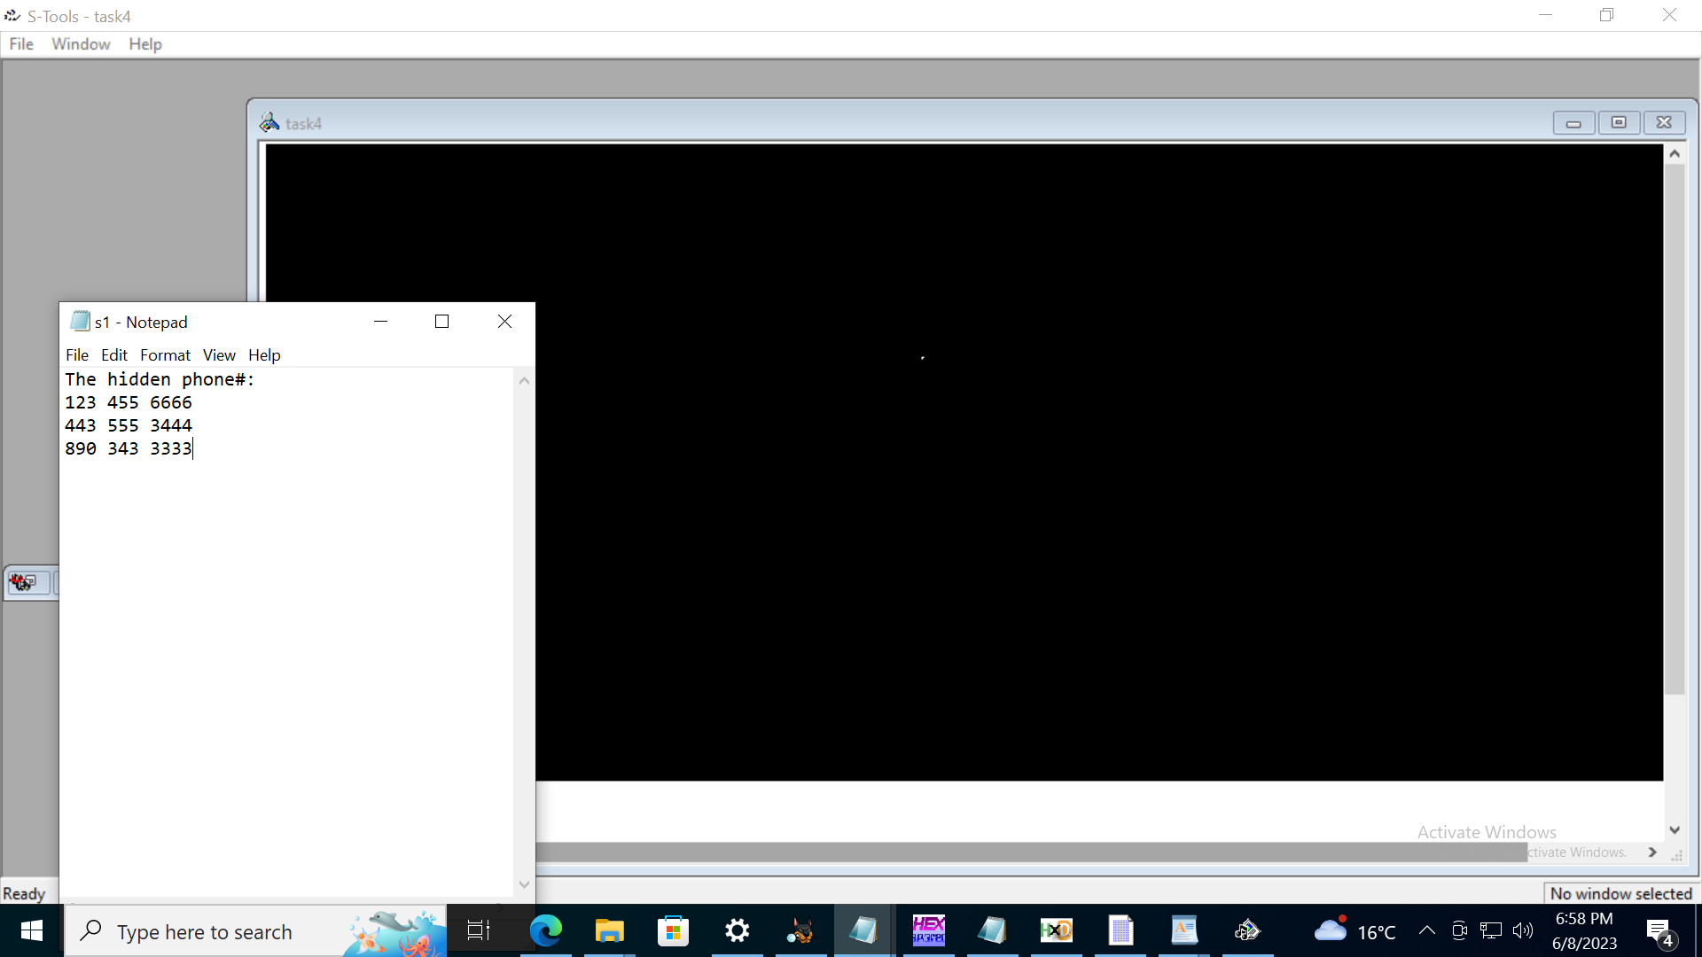

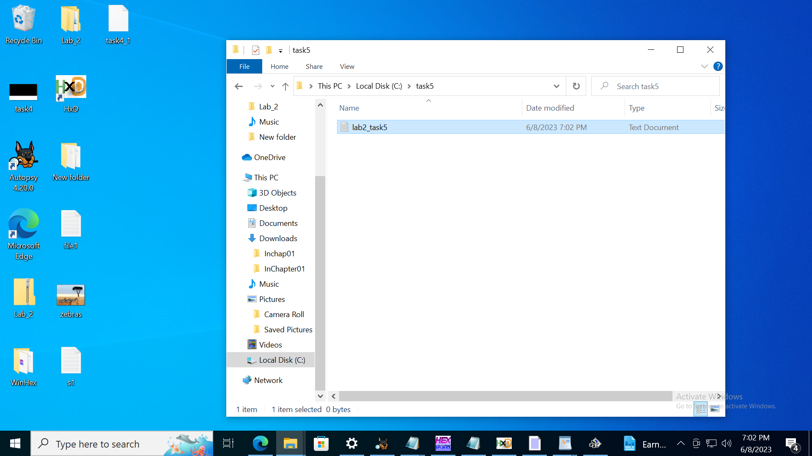

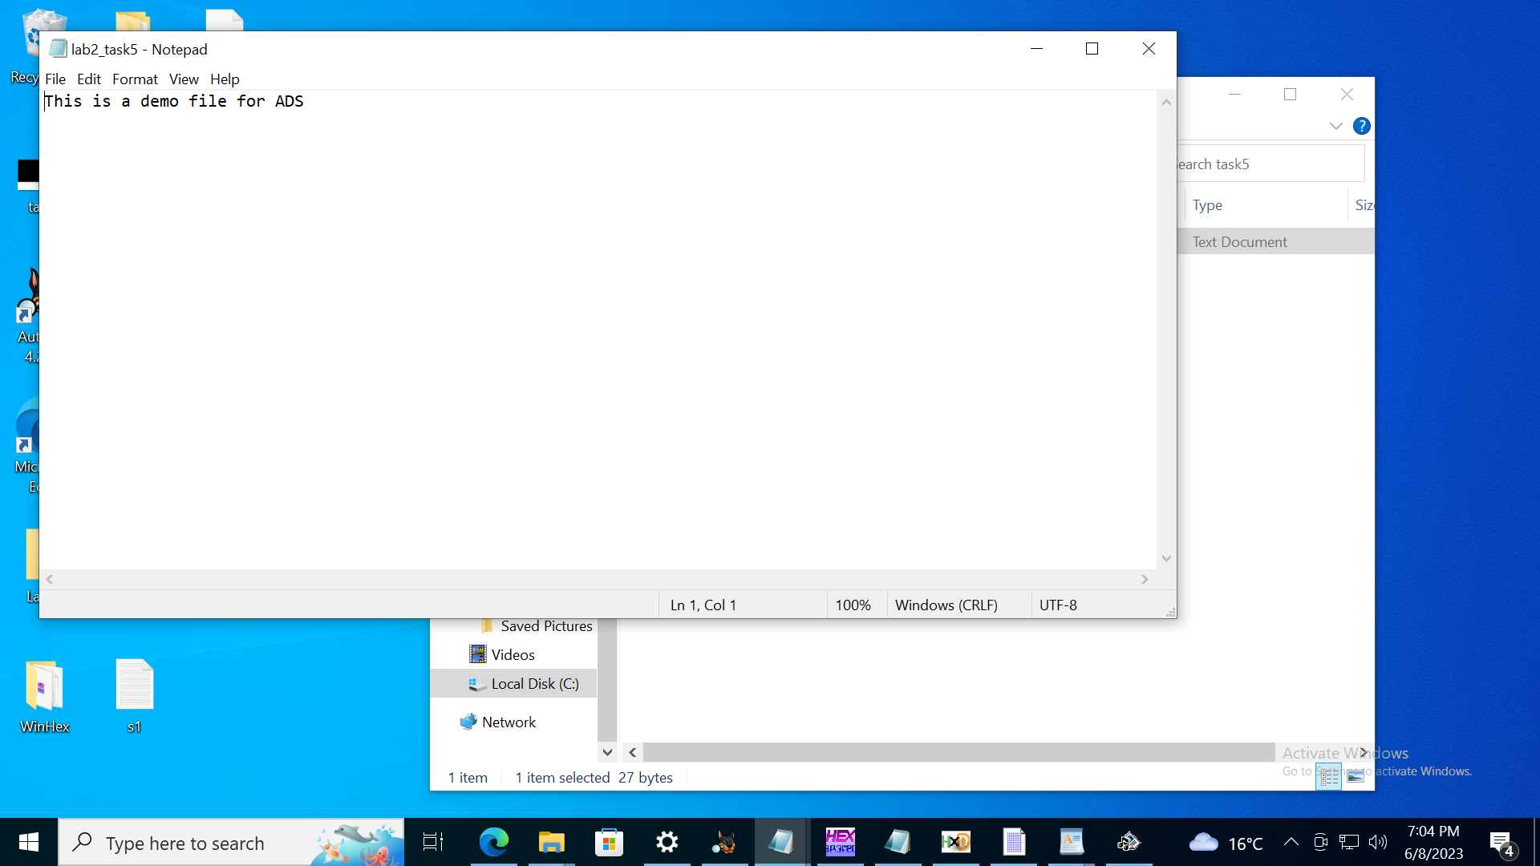

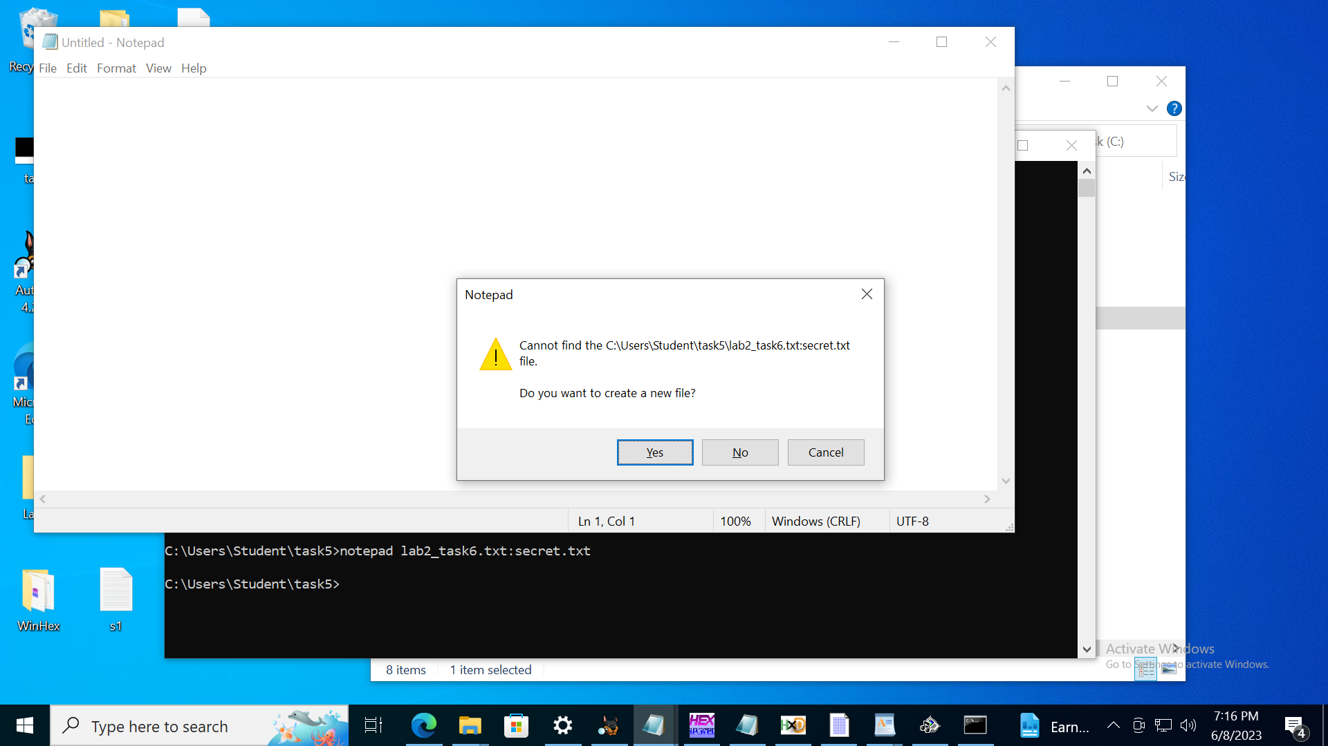

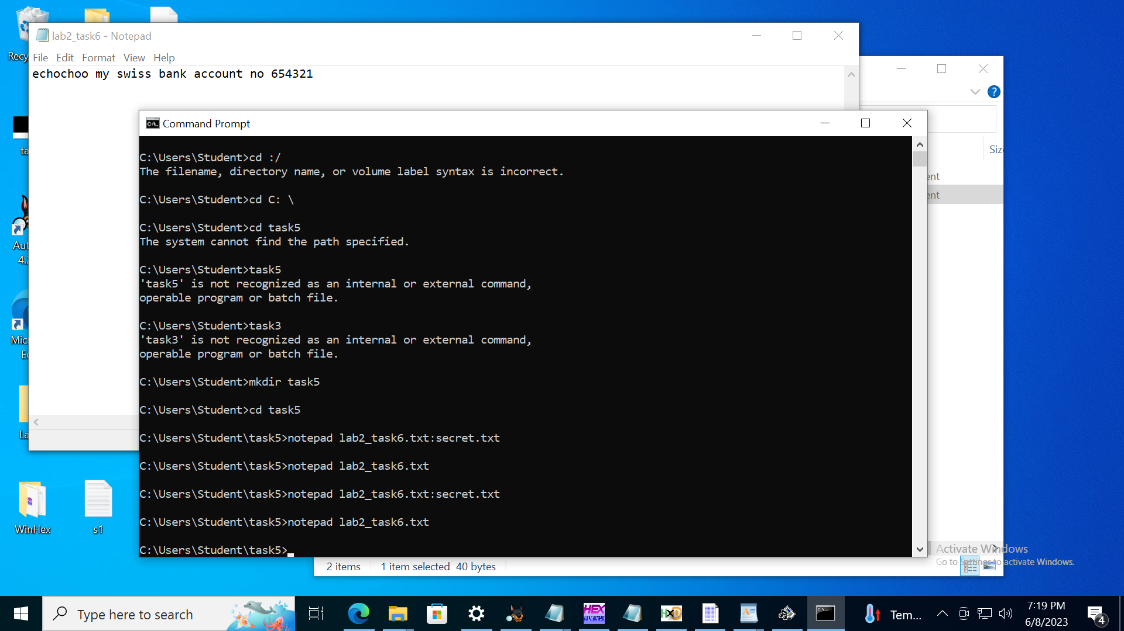

## **REFLECTION**

## **What is Steganalysis?**

Steganalysis is the process of finding and examining concealed information in digital media. It involves methods and techniques to find data that has been steganographically hidden. Steganalysis seeks to locate hidden data, identify the steganographic techniques used, and possibly extract or recover the hidden data. It includes LSB examination, statistical analysis, file format analysis, anomaly detection, and the use of specialized tools and algorithms. By identifying convert communication channels, malware distribution, and the unauthorized use of steganography to hide sensitive information, steganalysis is essential to computer forensics and cybersecurity. Its goal is to reveal concealed information and support the investigation of illegal activity.

## **What is the difference between cryptography and steganography?**

Both steganography and cryptography are methods for protecting data, but they take different approaches. The main goal of cryptography is to encrypt and transform data so that only authorized parties can decipher it. To safeguard the information authenticity integrity, and confidentiality, algorithms and keys are used. Steganography, on the other hand, is the practice of hiding data within seemingly innocent files or media in an effort to conceal the data itself. It focuses on embedding information within a carrier medium to transmit it covertly.

## **What is unique about messages transmitted using steganography?**

Steganographic messages have a special quality that makes them suitable for convert communication. Steganography hides information within seemingly innocent files or media, unlike conventional methods where messages are sent in plain sight, making it challenging for unauthorized parties to find. Steganogrpahy makes it possible to communicate invisibly and covertly by encoding data inside of digital media such as pictures, audio files, texts, and other types of digital media.

## **What are the basic steganographic concepts or inputs and outputs?**

The basic steganographic concepts involve the inputs, procedures, and results of steganography that are included in the fundamental steganographic concepts. Here is an overview each:

**INPUT:**

**COVER MEDIA:**

The carrier file or media on which the secret data will be stored is referred to as the cover media. It could be any type of digital file format, including an image, audio file, video file, text document.

**SECRET DATA:**

This is an acronym for the data that must be masked or buried within the cover media. It can be text, pictures, files for any other kind of information that needs to be kept private.

**PROCESSES:**

**Embedding**: it is the process of securing the cover media with secret data. Different methods are used, such as changing the audio file or the least significant bits (LSBs) of the pixel values in an image.

**Steganographic Algorithm:** Algorithm used to perform the embedding process is referred to as the steganographic algorithm. The methods used by various algorithms to conceal data can include LSB substitution, spread spectrum, or transform domain techniques.

**OUTPUTS:**

**Stego media:**  After the cover media has been used to embed the secret data, this is the final file or piece of media that is produced. Casual observations would suggest nothing has changed, by the secret information is there.

**Stego Key:** in some steganographic methods, the secret data may be encrypted before being embedded using a key or password. To extract the concealed information from the stego media, a stego key is required.

## **REFERENCE**

Steganalysis, the Counterpart of Steganography. (2016, December 22). Trustwave. <https://www.trustwave.com/en-us/resources/blogs/spiderlabs-blog/steganalysis-the-counterpart-of-steganography/>

GeeksforGeeks. (2023). Difference between Steganography and Cryptography. GeeksforGeeks. <https://www.geeksforgeeks.org/difference-between-steganography-and-cryptography/>

Fiscutean, A. (2021, September 15). Steganography explained and how to protect against it. CSO Online. <https://www.csoonline.com/article/3632146/steganography-explained-and-how-to-protect-against-it.html>